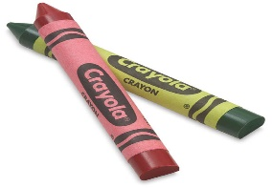
Learning Days Preschool Students Supply List
This Photo by Unknown Author is licensed under CC BY-SA-NC
Ages 2-3yrs
Our preschool year begins in August. Our preschoolers are required to have the following supplies in their cubbies by the first day of our preschool year or your Childs first day in our program.

(1in) 3 Ring Binder (Portfolio)

1 Box of Kleenex

(2) Writing Pads with no Lines ( for journaling)

1 Picture of your Child (for cubby)

1 Back Pack that includes: 1 Pack of Markers (Ages 3) (Non-Toxic) 1 Box of Large Crayons (Non Toxic) 2 Bottles of Glue (Non Toxic) Pencil Box (for markers/crayons)

Tennis shoes for Outdoor play

Disposable Hand Wipes

Extra Clothes in Cubbies/ Diapers for 2-year olds that are potty training

Naptime Linen (Fitted sheet and Small Blanket ) ***Please label all items ***We recommend that you buy a pair of scissors for your child to practice cutting skills at home and for homework assignments.

