After School Kids Club Daily Schedule

After School
2:30-2:45- return from school, wash hands, snack time.
2:45-3:00pm Snack
3:00-3:15- Group time, talk about our day, Kids worship, etc.
3:15-4:15- After School Kids Club Activities ( Music, Art, Literacy, Cooking, Science, Drama, etc.)
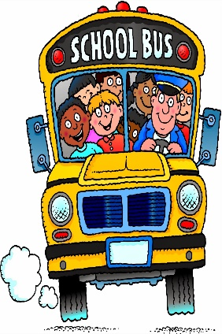
4:15-5:00- Outdoors

5:00- 5:30- Homework Club
5:30- 6:00pm- Clean-up/Prepare for Home

