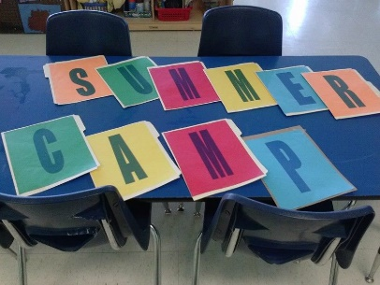

Learning Days- ATL Summer “Fun” Camp “2024”
Registration Form (Grades K-6th)
(See attached flyer for fieldtrip fees)
Camp Tuition is $160 week | Georgia Caps Accepted
If your child is not currently enrolled at Learning Days, a (non- refundable) $100 Registration fee must be paid to secure each child’s camp enrollment.
Please complete this form and return to Learning Days no Later than May 1, 2024 to assure your child’s enrollment in our Summer Fun Camp. Summer Slots fill fast, so don’t wait to return the form!
Child’s Name_______________________________ Age__________ T-Shirt Size_______
Child’s Name_______________________________ Age__________ T-Shirt Size_______
Parent’s Name______________________________ Wk#__________________
Address________________________ City, State, Zip______________________
Cell #___________________________ email_____________________________
List any Allergies or Health Problems____________________________________

In case of an emergency my child must be taken to the following hospital: __________________________________________________________________
Physician’s Name___________________________ #_______________________
Your child will need the following supplies for Summer Camp: Tennis shoes, (2) camp T-shirts, Sunscreen or sun hat, children may bring sports equipment for sports camp days, camera, Library Card, Journal (spiral notebook) and bring bottle water/back pack for outdoor field trips. ** Learning Days is not responsible for any lost items.
** Your child will receive 2 complimentary Camp shirts. Additional shirts cost $15/each
____ I understand that all fieldtrip fees ($100.99) and camp supplies are due on or before May 28, 2024. * Field trip fees must be paid via tuition express.
____ I agree to give a 2 week notice in the event my child no longer needs to attend the camp or I will be responsible for tuition until the end of the 2024 Summer Camp.
___ I give Learning Days permission to transport my child on summer camp fieldtrips.
Parent’s Signature__________________________________ Date____________
www.learningdays.com

