
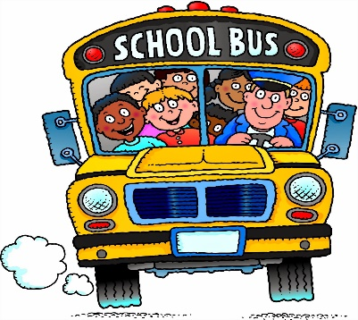
Learning Days-Atlanta location
This Photo by Unknown Author is licensed under CC BY-SA

After School Kids Club Registration
2026-2027
Child’s Name______________________________________ Age_______
Child’s Name______________________________________ Age_______
Parent’s Name_________________________ Cell or work #_________________
Name of School_________________________________ Grade________
We Currently Transport to: ( circle one)Kennesaw Elementary & Big Shanty
(Select all that apply to your childcare needs)
____ After Care ___ School breaks
____ I agree to notify Learning Days in the event my child will not attend the program.
____ I will need childcare on Early Dismissal Days/Professional Development Days.
____ My child will attend the program during winter break or spring break
____ I want my child to do homework while at the center after planned after school activities. (Teachers may offer assistance, but are not required to tutor children)
___ My child will be in attendance for ___ Snack.
___ I understand that I must call the center if my child will not be riding the van.
Van Procedures
The van will leave the building no later than 1:45pm to pick up-off at schools. We return to the center by 2:30pm in the afternoons. The children must sit while riding in the van, use quiet voices in the van and wear seat belts. If your child weighs less than 40 pounds, you may be asked to provide a car seat. Children that violate the van rules may be suspended from the van for up to 48 hours.
Rates: After kids Only |___$150/wk ___ $50/day for school closings
** In the event of winter, spring or summer break, tuition is $160/week.
*Tuition is due two weeks in advance and may vary in the event your child is in care full-time. (See your Payment agreement for tuition prices and policy)
Parents Signature___________________________________ Date____________________

