
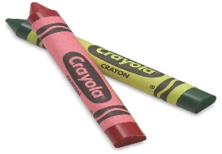
Learning Days Pre K Students Supply List
This Photo by Unknown Author is licensed under CC BY-SA-NC
Ages 4-5yrs
Our School year begins on August 3rd. Your child will need the following supplies by the first day of our preschool year or on your Childs first day in our PreK program.
PreK Uniform:
Navy Blue shirt
Khaki bottoms ( Pants, skirt or shorts).
( Buy on amazon, Walmart, Target or Children’s Place)
Supplies
Tennis shoes for outdoor time

Plastic 2 Pocket Folder

Extra clothing in cubby

1 Box of Kleenex/ Disposable Wipes

Back-Pack
3 Inch Binder
Twin size Fitted sheet and small blanket for cot

Water bottle for outdoor time ( reusable)

***Please label all items ***We recommend that you buy a pair of scissors for your chld to practice cutting skills at home and for homework assignments.

